**2022-23 EVEN SEMESTER SOUVENIOR**

**Duration-**December 2022 – April 2023

**1.Date:** 25/02/2023 & 26/02/2023

**2.Name of event: HACKATHON**

**3.Title of the specific event: NATIONAL LEVEL ONE DAY PRODUCT DEVELOPMENT HACKATHON 2023**

**4. Image : -(ONLINE MODE)**

**5.CONTENT :**

National level one day product development hackathon 2023 conducted by CSI - Chennai Chapter in Association with LOYOLA- ICAM College of Engineering and Technology (LICET) on 25th and 26th February 2023 through Online mode.

The students Dhiyanesh and Bhuvaneshwaran from 3rd year CSE won 2nd position in Agriculture and health care stream & and the students Cavin Kumar and Legin from 2nd year CSE won 2nd position in Smart city and Online Education Stream. Both teams received cash amount Rs.2000(per team).

**2022-23 EVEN SEMESTER SOUVENIOR**

**Duration-**December 2022 – April 2023

**1.Date:** 03/03/2023 & 04/03/2023

**2.Name of event: HACKATHON**

**3.Title of the specific event: 2ND EDITION POORNIMA HACKATHON - 2023**

**4. Image :**

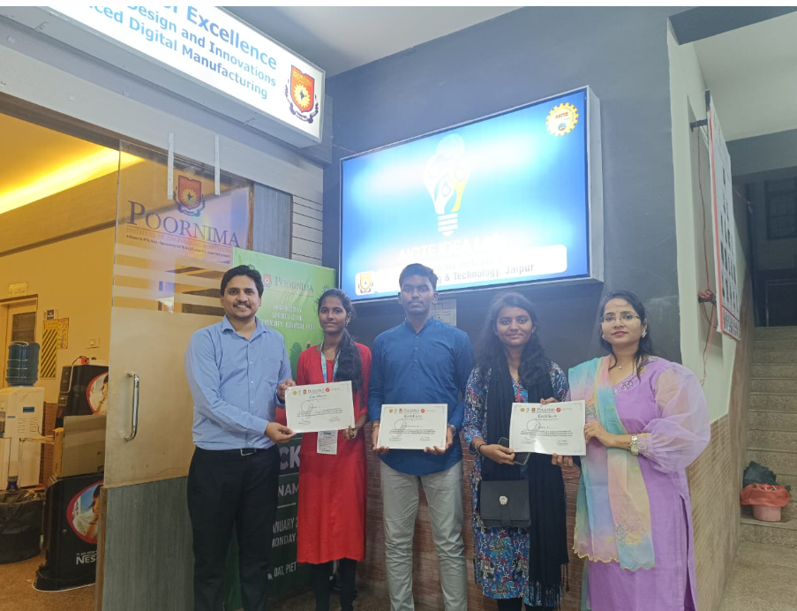

**5.CONTENT :**

The POSTMAN API TRACK in Poornima Hackathon 2023 “THE SMART CITY” held on 3 rd and 4 th march organized by PIET AICTE IDEA LAB &amp; Poornima Institute of Engineering and Technology, Jaipur. The students Sethulakshmanan, Vasithra, Vidhyasri from 2nd year CSE is the winners of POSTMAN API TRACK.

**2022-23 EVEN SEMESTER SOUVENIOR**

**Duration-**December 2022 – April 2023

**1.Date:** 03/02/2023 & 04/02/2023

**2.Name of event: HACKATHON**

**3.Title of the specific event: 5th TECHNOVATION HACKATHON**

**4. Image :**

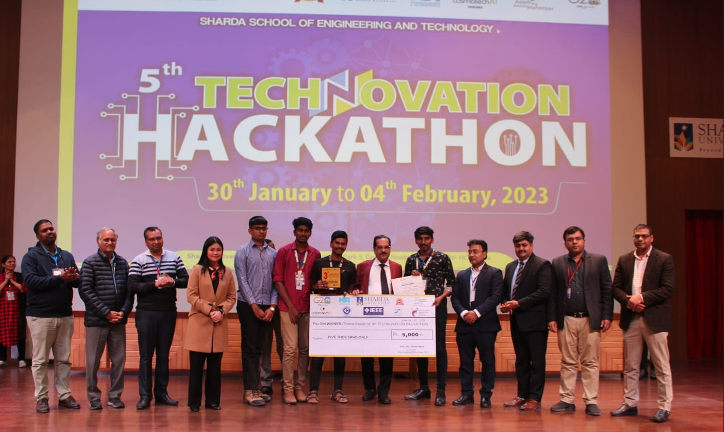

**5.CONTENT :**

5 th Technovation Hackathon conducted by SHARDA UNIVERSITY, Noida on 3 rd and 4 th February 2023.The students Eugine Carmel , Sanchith Abinav , Calvin Davis, Ben Stanes from 2nd year CSE won 3rd position and received cash amount Rs. 5000.

**2022-23 EVEN SEMESTER SOUVENIOR**

**Duration-**December 2022 – April 2023

**1.Date:** 14/09/2022 & 15/09/2022

**2.Name of event: HACKATHON**

**3.Title of the specific event: NATIONAL LEVEL SRGEC HACKATHON 2022 [SGH2022]**

**4. Image : -**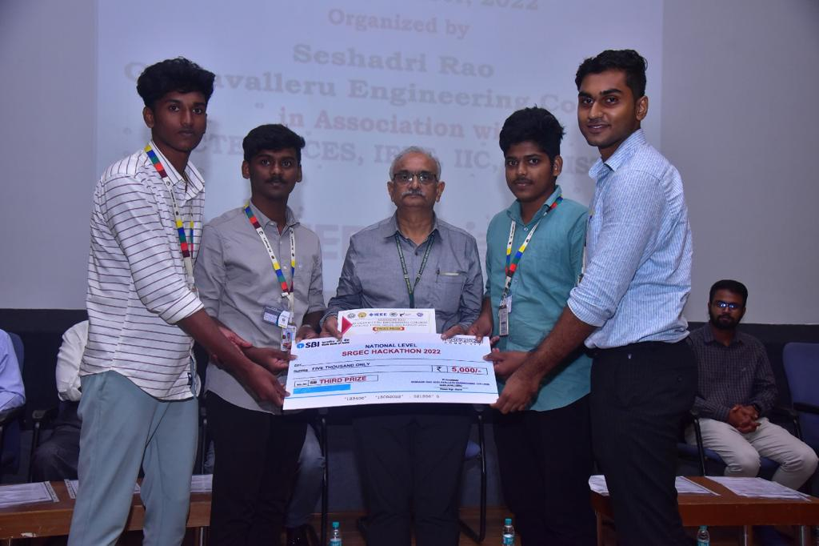

**5.CONTENT :**

National level SRGEC hackathon 2022 (SGH2022) was conducted by SRGEC in Association with AICTE SPICES,IEEE,IIC,CSI,ISTE on 14th and 15th September 2022 through Physical mode.

The students Joiyson Jawahar T,Joel William A,Jesro Nithin A & Kishore M from 2nd year IT won 3rd position in Village empowerment stream with the project title “THE SMART BIN” and received cash amount Rs.5000.

**2022-23 EVEN SEMESTER SOUVENIOR**

**Duration-**December 2022 – April 2023

**1.Date:** 10/02/2023 & 13/02/2023

**2.Name of event: HACKATHON**

**3.Title of the specific event: SMART AGROTHON 2023**

**4. Image: - (OFFLINE MODE)**

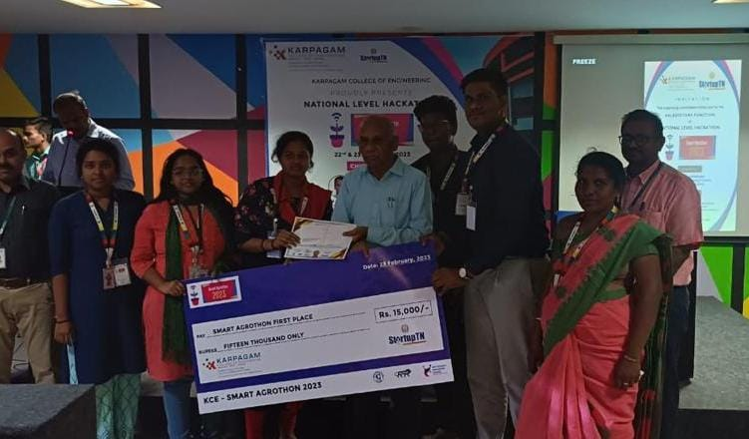

**5.CONTENT:**

**The Smart Agrothon 2023 aims to bring together teams from across India who possess fresh perspectives, disruptive approaches, cutting-edge research, and smart-thinking skills to address the significant challenges related to agriculture. This event seeks to accelerate the development of technology-based solutions that can assist farmers in overcoming their difficulties and enhancing their farm returns. We have submitted 4 team projects for consideration, and 2 of them have been shortlisted. Furthermore, 1 of our team projects has been awarded a cash prize of INR 30,000.**